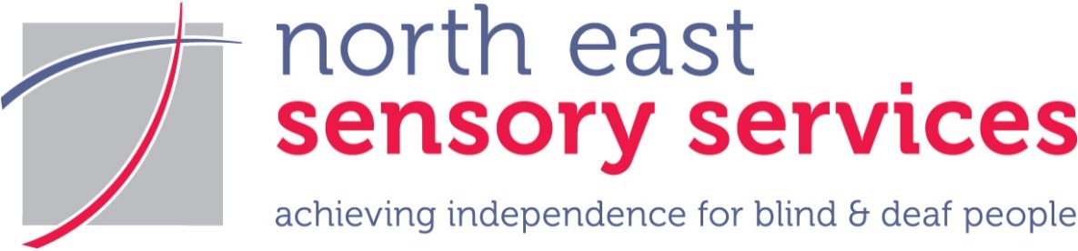
NESS NEWS

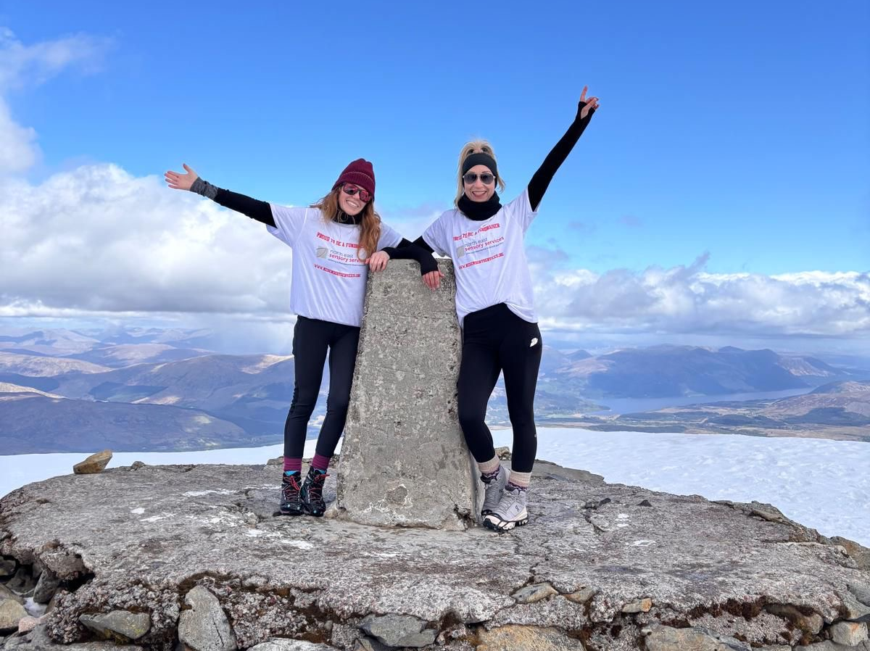

SUMMER 2026
North East Sensory Services Newsletter
www.nesensoryservices.org

CONTENTS
Did you know? 2
Still making jewellery with macular degeneration 2
Success for Scottish Deaf darts team 4
Emma scales Ben Nevis in aid of NESS! 4
Congratulations and thank you to Duncan Milne! 5
NESS Race Night is a fundraising winner 5
Celebrating 150 years at NESS 6
Promoting digital access 6
“The Singer” tours Scottish theatres from July 7
Aberdeen News 8
Lipreading Classes in Aberdeen 8
Angus News 9
Angus residents drop in to NESS 9
Moray News 9
An update from our Moray Young People’s Sensory Service 9
Your Tesco vote results in £1,500 for our Moray YPSS! 10
Meeting up in Moray – the social inclusion groups 11
Keeping connected in Moray 12
NESS CONTACT INFORMATION 12
ABERDEEN 12
DUNDEE 12
ANGUS 13
MORAY 13

This magazine is available in large print (pt. 14), jumbo print (pt. 24), braille, CD, email and BSL DVD. If you are able to receive this newsletter by email, please let us know and help us save postage and paper. If you have not received this in your desired format or do not wish to receive it at all, please contact us so that we can change our records accordingly.
Charity Registered in Scotland SC009537 Company Limited by Guarantee SC155630. All views expressed in the newsletter are the views of individual contributors and do not necessarily reflect the view of North East Sensory Services
[Cover Image caption: NESS’s Emma Welsh and her friend Carolynne wave from the summit of Ben Nevis after their sponsored climb. See inside for the full story!]

Did you know?

Still making jewellery with macular degeneration

Being diagnosed with Macular Degeneration was a huge shock for Robin, who is a professional jeweller, keen bird watcher and amateur radio enthusiast.
Robin Key, 81, was diagnosed with wet Macular Degeneration in 2019 when he was being assessed for the removal of cataracts. Macular Degeneration is the most common cause of registerable sight loss in the UK and involves a loss of central vision.
Robin says, “I initially was told I had a cataract which needed to be removed. My right eye suddenly started to become a bit affected, but I assumed it was the cataract. When I was told it was Macular Degeneration, I was referred to the Eye Clinic at Ninewells Hospital in Dundee. I’d heard of Macular Degeneration but didn’t really know what it was. About 3-4 weeks later, I started to notice that there were kinks in the trees, that they weren’t straight. And then the sight went altogether in the right eye, and it was too late for any treatment for the wet Macular Degeneration. Because it only affected one eye, I was still able to drive and to get about.
“In 2023, I went for a routine eye check and the optician noticed something on my left eye, which then seemed to disappear. A few weeks later, I noticed my sight had become a bit foggy, and with more knowledge about Macular Degeneration, I went back to the optician. By mid-afternoon, I’d had a phone call from the local Eye Clinic to be there at 9.30am the following morning. For the last two years, I’ve been getting injections in my left eye every two months, which is slowing down the deterioration of that eye. It’s the middle of my eyes that are damaged so I can still see a little bit out of the side of my eye.”
Robin continues, “Getting the diagnosis was an absolute disaster to me, because I use my eyes so much, for work and hobbies. All of a sudden, I was having restrictions imposed on all those things, and I was having to change things quite a lot because of it. Even basic things, like watching the television, were becoming a chore rather than an enjoyment. It can be a very lonely place, losing your sight.”
Robin started work as a Merchant Navy radio officer, before working onshore, and in the oil industry. He fell into jewellery making when he applied for a jewellery making course, which was the only course available at Robert Gordon University. Robin started a 30-year career in jewellery making, which continues today.
Robin first got in touch with NESS in 2023, who were able to support Robin to resolve a number of difficulties he was experiencing because of his sight loss. NESS’s local Vision Rehabilitation Specialist visited him at home, told him about other NESS services, and made a number of recommendations, including changing the light bulbs to stronger ones and introducing him to a symbol cane. Robin also got support from NESS’s ICT officers to learn to use an Apple Mac. While Robin had used computers before, he wasn’t familiar with Apple Mac. He had been told that the Apple Mac had better accessibility features.
Robin uses a smartphone. Robin continues, “I use dictation for using the phone, and it reads my messages to me. I tell my phone to “phone home”, for example. It also connects directly to my hearing aids. You need organisations like NESS, where somebody can show you how to use these functions and apps on your phone.”
As a keen birdwatcher, Robin found he could no longer identify birds. Robin continues, “With advice from the ICT officer I bought myself a microphone and a good recorder so I could record the birdsong. I’ve also got the Merlin app, which picks up birdsong and identifies it. The Eye Clinic gave me a small portable telescope, which helps with the birdwatching as well as reading bus timetables.
“I’ve also got two handheld magnifiers that I got from the Eye Clinic. Some of the magnifiers also have LED lights, which gives better lighting, and I use a magnifier with a light for my jewellery making or repairs. I’ve also got special, very powerful magnifying glasses, called an Optivisor, to help with the jewellery making.”
Robin continues, “I’ve found different ways for making jewellery and make it by proxy by teaching other people – this helps to keep me involved in the aspects of jewellery making that have become really difficult. I can also make a wax mould for a piece of jewellery, and I send that away for the jewellery to be cast. Once it comes back fully cast, I can polish it and add gemstones. These are tactile stages so are easier to do.”
Robin describes the Seeing AI app as an “absolutely amazing piece of technology”. He explains further, “You can use it for all sorts of things. It'll tell you what money you have in your hands, it can describe a room or a street or anything to you. It can describe a person. If you show it a face and put a name to the person, then when you go into a room it will tell you if that particular person is in the room. I even used it to help me study for exams. Every few months, a new development comes along, but it’s a free app, available worldwide and in multiple languages.”
Robin is also a keen user of amateur radio and has had to learn a lot of technical information and pass exams to be licensed to use it. Robin says, “The Radio Society of Great Britain are very supportive when you take the examinations. They will have people reading the questions to you and writing down your answers and they will give you a longer time to complete the exams.”
Robin continues, “I would really like to thank NESS, the Eye Clinic and Eye Clinic Liaison Officer and most of all my wife for all the support they’ve given me. It really was a big shock when I lost my sight. I feel very strongly that I want to share my experiences with others as they might pick up something that they find helpful”.
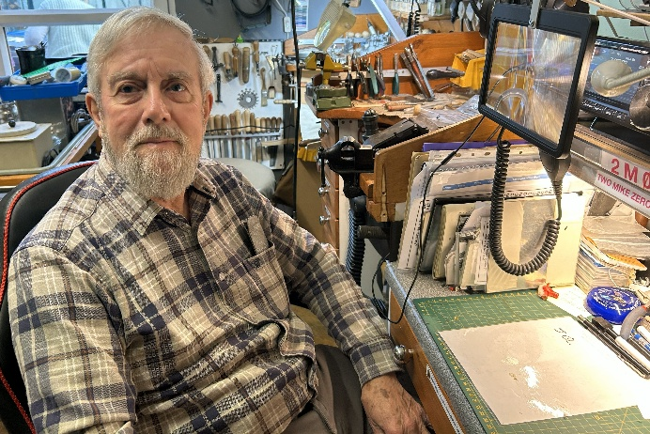
Robin’s personal experiences of sight loss show how getting information and support helps to develop workarounds, meaning Robin can continue to do the hobbies that mean so much to him.

[Image caption: Robin sits in his home-based jewellery workshop in front of a workspace with spot lighting and a magnifier. A wall of tools can be seen in the background.]

Success for Scottish Deaf darts team

Congratulations from everyone at NESS to Daniel Morrison, from Aberdeen, who won the British Deaf Sports Council (BDSC) Men’s Single darts competition in Leicester in May 2026. Daniel also won the mixed pairs competition along with Margaret Campbell from Glasgow. Ilona Virginia from Dundee won the Ladies Singles competition. Congratulations from everyone at NESS to Margaret and Ilona for winning their competitions.
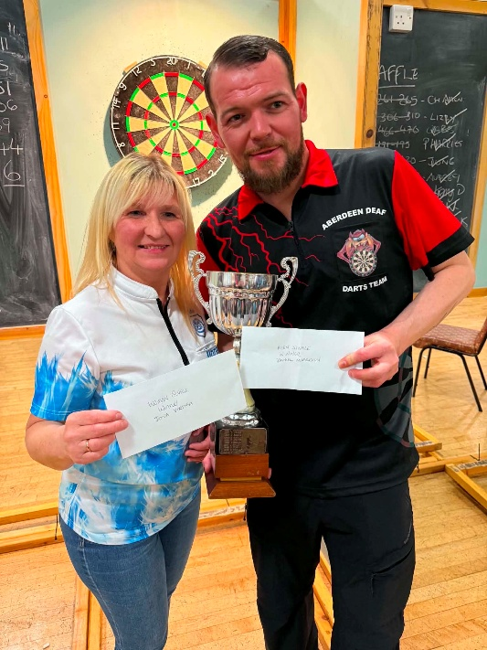
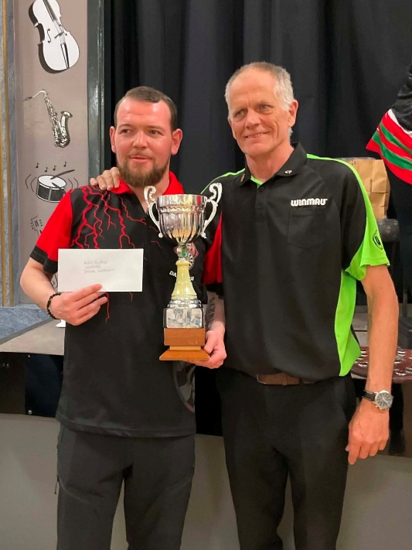
[Image caption: Margaret (on the left) and Daniel (on the right), both holding their winners’ trophy. Each of them holds a cheque. A darts board can be seen behind them.]
[Image caption: Daniel Morrison (on the left) receiving his trophy and a cheque.]

Emma scales Ben Nevis in aid of NESS!

Congratulations to Emma Welsh, NESS Community Partnerships Coordinator, and her friend Carolynne Mellough - who completed their ‘NESS to Nevis’ challenge by climbing Ben Nevis in May. Thanks to their efforts and the wonderful generosity of supporters, they raised an outstanding £4,035.45 for NESS!

Emma took on the challenge inspired by her son and the other children, young people and adults who live with sensory loss, and who overcome barriers every day. Emma says: “Ben Nevis pushed me out of my comfort zone, but it was all worth it knowing we were helping raise funds for such an important local charity. We’ve been overwhelmed by the support – it’s a reminder of the power of community and how much people care. Every donation will help support NESS and the life changing work that it does.”

Congratulations Emma and Carolynne - what an achievement!

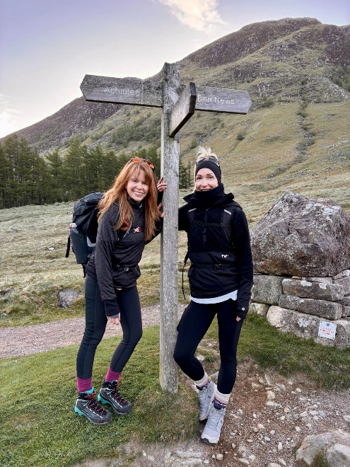

[Image caption: Emma (on the left) and Carolynne, wearing hillwalking gear, stand smiling beneath a wooden signpost pointing up Ben Nevis.]

Congratulations and thank you to Duncan Milne!

Huge congratulations and a big NESS thank you to Duncan Milne, who completed the London Marathon on Sunday 26th April. Duncan raised a wonderful £1,396, split between NESS and Aberdeen Grammar Rugby Club Minis. Duncan chose to raise funds for NESS because his two children, both of whom live with hearing loss, have benefitted from our Young People’s Sensory Service (YPSS).

Duncan was one of 59,000 runners to complete the gruelling 26.2 mile route from Greenwich to the heart of Westminster – taking in several famous London landmarks including Tower Bridge, Canary Wharf and the Elizabeth Tower, which is home to Big Ben. Paying tribute to everyone who sponsored his wonderful achievement, Duncan says: “Thank you to everyone that supported me. It meant a lot and kept me going throughout.”

Thank you again to Duncan and all his supporters from everyone at NESS!

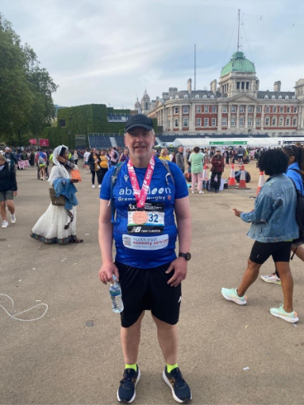
[Image caption: Duncan Milne stands in his running gear with people and London buildings in the background, proudly wearing his London Marathon medal.]

NESS Race Night is a fundraising winner

A huge NESS thank you to everyone who supported or attended our fundraising race night at Aberdeenshire Cricket Club on Friday 1st May. We are delighted to have raised an incredible £2,761.55 for NESS!

The night was hosted by the Aberdeen-based Khyber Pass Association (KPA), who did a wonderful job of managing all the bids and games (kindly sponsored by Airhop). The event was also made possible by sponsorship and prize donation from the local business community, and we are so grateful for this invaluable support.

The novel twist on the night was the use of pulley horses – where the jockeys were powered by our willing participants! This resulted in lots of friendly competition, banter and laughter. As one attendee said afterwards: “I honestly didn’t know what to expect, but the race night was so much fun! The pulley horses made it feel really unique and had everyone laughing and getting involved. A fantastic evening for a great cause.”

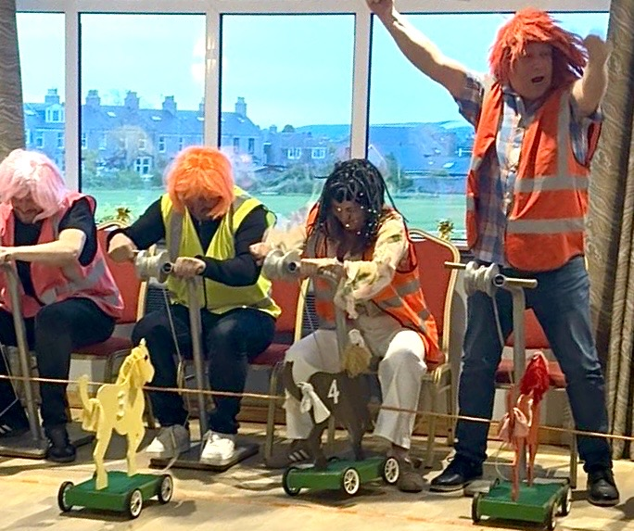
[Image caption: a row of people dressed in colourful wigs and high-vis gilets concentrate on racing their pulley horses across a wooden floor. One man stands with his arms aloft, in a "winner" pose.]

Celebrating 150 years at NESS
In 2029, NESS will be celebrating its 150th anniversary, and we are planning to mark this amazing achievement with a series of celebratory events for everyone across all the areas NESS works in. Marking our 150th anniversary will also offer an opportunity to raise awareness of NESS, and of sight loss, hearing loss and Deafness, as well as provide opportunities to raise vital funds for NESS services.
As we start planning these events, we would like to invite anyone interested in getting involved to get in touch. Do you have an idea of how you would like to celebrate this great milestone? Would you like to get involved in planning the celebratory events to make them the best they can be? We have a small group of staff starting to discuss ideas, and we would welcome anyone who would like to get involved to get in touch and take part in whatever way you would like to.
NESS started in 1879 as the Aberdeen Town and County Association for Teaching the Blind at their Homes, before becoming Grampian Society for the Blind in 1980. We became NESS in 2010 after becoming the first fully integrated joint sensory service in Scotland, supporting people who are Deaf or hard of hearing as well as people with sight loss.
If you would like to get involved in any way, big or small, please get in touch in any of the usual ways – everyone is welcome. We will make meetings as inclusive as possible, including providing BSL interpreters.
We will keep you informed in the NESS News about our plans as the ideas start to take shape. There will be plenty of opportunities for people to join in at later stages of the planning or to get involved in particular events or projects, so please do get in touch – we'd love to have you involved.

Could you switch to a digital NESS News?

As the cost of printing and posting continues to rise, we would encourage you to get a digital version of the NESS News. Increasing digital access also reduces the environmental impact of printing and posting. At the moment, we post out the NESS News in a number of accessible formats, including standard print PDF, jumbo print (Word), and Braille. We also post our audio versions on CD, and BSL videos on DVD. BSL versions are also available on our YouTube channel. We also email standard print size (PDF) and standard print (Word) versions out together.
To help make digital access easier, we have set up a page on our website that will include all of the different accessible versions of the NESS News, apart from Braille.
This includes:
- Standard print PDF
- Standard print Word
- Jumbo print Word
- Audio version – link to the MP3 audio file
- BSL version (with audio and subtitles) – link to the MP4 video file.
The link to the website page is https://www.nesensoryservices.org/newsletter/.
When the NESS News is published, we will also post on our social media pages that it has been published with a link to the new website page.
We will continue to send the NESS News out in the way that you have chosen, but would really appreciate it if you were able to move to receiving a digital version. Please get in touch in any of the usual ways if you would like to move to a digital version, so we can change our records. If you would like to go digital but are unsure about it, please get in touch – we will provide support for you to manage the change.
We are still working out the easiest way of making digital access as straightforward as possible, so please get in touch if you have any questions, suggestions, or ideas.

“The Singer” tours Scottish theatres from July

The Singer is described as “a bold, thrilling new gig-theatre drama”, and is performed in BSL and spoken English with captions throughout. It tells the story of Joe, a deaf artist who “sings” with his hands, and Andy, a washed-up musician desperate to make a comeback. The drama tells the story of what happens when the two form an unlikely creative partnership. Featuring music and lyrics by KT Tunstall and based on the short film The Singer by Cora Bissett and Jamie Rea, The Singer is “a powerful story of music, identity and connection, and the fight for a deaf artist to be truly seen and heard”.

A Dundee Rep Theatre and Solar Bear production in collaboration with Aberdeen Performing Arts and the Traverse Theatre, it is suitable for ages 10+. The running time is 1 hour 15 minutes.

The Singer can be seen at the following venues:

Dundee Rep Theatre, Dundee
29th – 31st July and 23rd – 26th September 2026

Traverse Theatre, Edinburgh
4th – 30th August 2026

The Lemon Tree, Aberdeen
9th – 12th September 2026

Citizen's Theatre, Glasgow
15th - 19th September 2026

For tickets, contact the individual venues or visit https://solarbear.org.uk/productions/the-singer/ for further information and booking links.

If you are inspired by this story, you may be interested to know that Solar Bear runs the Deaf Youth Theatre (DYT), based in Glasgow, for young deaf/hard of hearing/deafblind people aged 11 – 21 years. They run weekly workshops, create original new shows and make films. More details are at
https://solarbear.org.uk/deaf-youth-theatre/.

Aberdeen News

Lipreading Classes in Aberdeen

We are starting a new beginner’s “Lipreading and Managing your Hearing Loss Class” in September for people living in Aberdeen.
The class will run fortnightly on a Monday from 11am – 1pm in our building at John Street. The course will run for 2 years, with breaks during holidays. Classes are relaxed and informal, and you can go at your own pace.
During the 2 years you will learn to identify visible lip shapes, learn coping strategies, and get information on supportive equipment available, some of which will be demonstrated during the class. We will discuss some of the types and causes of hearing loss as well as how to get the most from your hearing aids.
Joining a Lipreading Class is an ideal way to meet people facing similar challenges to you. You can share experiences and pick up lots of tips and practical information to help you cope with your hearing loss.
There is no charge for the classes.
Previous participants have said:
“Having had the chance to attend a lipreading class has been a positive experience for me, I do feel I cope better with my hearing loss. I’m more aware of how to help myself and my confidence has improved.”
“I am grateful to NESS for the opportunity to join a lipreading class. The lessons are always very informative, enjoyable, and fun.”
If you would like to find out more or book a place on the new Lipreading class, please get in touch in any of the usual ways.

Angus News

Angus residents drop in to NESS

Over the past year, we have organised a number of drop-in sessions in Angus, thanks to funding support from Angus Society for the Blind. Our latest drop-in session took place at The Cross in Forfar, which is where our Angus office is now based.
These drop-in sessions were initially set up to introduce people to technology and our ICT service but have grown over the past year to include all of the Angus-based services, including ICT, Fieldwork and Rehab, Employment support, daily living aids, and our Young People’s Sensory Service (YPSS).
The drop-in sessions are proving to be a valuable opportunity for people in Angus living with sensory loss to find out more about what NESS does. There are opportunities to meet each other and get to know the NESS staff.
We will be running more sessions in the coming year, thanks to Angus Society for the Blind’s support, so please look out for information about the next drop-in session. The next session will probably be sometime after the summer holidays in the Autumn. In the meantime, if you have any questions about your sight and/or hearing loss, please get in touch or use the duty service.

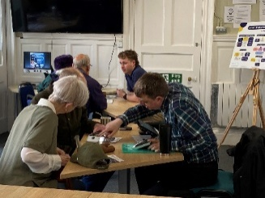
[Image caption: Kevin and Ryan, our ICT officers, demonstrating different pieces of equipment to visitors at our last drop-in session.]

Moray News

An update from our Moray Young People’s Sensory Service

Our Young People’s Sensory Service (YPSS) supports children and young people living with serious sight and/or hearing loss, helping them to grow in confidence, become more independent, make friends and develop their social skills, and forge ambitions for the future. Youngsters living with a serious sensory loss can sometimes feel isolated, “different”, and excluded from mainstream activities. Our YPSS gives them the opportunity to take part in a wide range of challenging activities, delivered in a safe and supportive environment, helping them to focus on what they can achieve – which has a positive impact on their lives at home and in school. We also bring our children and young people together through social clubs, providing a space where they can compare experiences, make friends and support each other, all of which helps them to feel more socially confident.

Our team have built positive relationships with local community organisations and activity providers, who play a big role in the success of our YPSS. One example is The Bosie, a welcoming family centre on Elgin High Street, which runs cooking sessions for our YPSS during the school holidays and also hosts the lunch club for our primary school aged children during term time. Iain Simpson, our Moray YPSS Youth Worker, praises the regular team of Sarah, Nicole and Gail, and says: “They have such a good relationship with the kids, it makes everything flow well when we're there”. While the food is being cooked, the youngsters have the chance to play board games or Lego, have fun with puppets, and there are sofas where the children can “chill out and socialise themselves without having an adult overseeing them all the time”.

Another regular – and very popular - activity is horse riding at Cranloch Riding Centre, where there are sessions during every school holiday. Iain again mentions the vital role that owner Heather and her daughter Fiona play in the success of these sessions. They are both very experienced at working with our young people and tailoring the riding sessions to their needs with a great amount of patience, helping our youngsters to grow in physical confidence and improving their spatial awareness. The family also do tours of the farm, which include a petting session with some of the lambs during the Easter holidays.

Our young people also enjoy ice skating at Moray Leisure Centre, again with a huge boost to their balance and confidence, and the team there have been very helpful and accommodating in planning sessions for the school holidays. At Easter, our Moray youngsters travelled to Aberdeen and took part in a climbing session at Transition Extreme. As well as broadening their activity horizons, this also gave them the chance to meet up with our Aberdeen group – something which our YPSS team plan for during every school holiday programme to further widen our young people’s social circles.

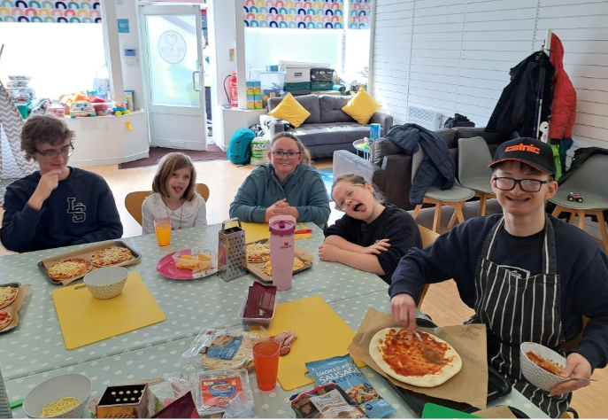
[Image caption: A group of five young people sit smiling around a table, with the pizzas they have made during a cooking session at The Bosie.]

Your Tesco vote results in £1,500 for our Moray YPSS!

Thank you so much again to everyone who voted for NESS in-store at Tesco Extra, Blackfriars Road, Elgin over the winter. We are delighted to announce that our Moray Young People’s Sensory Service (YPSS) received the most in-store votes and has been awarded £1,500! As you read above, taking part in a wide range of activities has direct, positive impacts on the lives of the youngsters we support. This award will help to fund our activity programme over the next year and make a big difference to our children and young people.



[Image caption: “Thank You” written in a graphic style]

Meeting up in Moray – the social inclusion groups

Since the changes in Moray have happened, the social inclusion groups in Elgin, Keith, Buckie and Forres - as well as the craft group - continue to meet regularly, providing opportunities for people living with significant sensory loss to get together, enjoy each other’s company, and provide vital informal peer support. Meetings often include outings, talks or entertainment, and new outings are being planned for the summer, including a trip on a trishaw – a three wheeled cycle designed with a seat for two in front of a bicycle.
The Elgin based craft group continues to be busy making crafts, including knitted toys, and bags in various sizes with colourful materials and patterns, amongst other craft items. These are then sold locally to raise funds for crafting materials.
If you or someone you know would like to get involved in the Moray based social groups, please get in touch with NESS.
We are always looking for volunteers to help run the social groups and to pick people up and take them home after the sessions. If you, or someone you know have a couple of hours spare a week and would like to support our social groups, please get in touch with NESS.
We are also looking for a community bus that we can rent/hire to help with transport. If you are aware a community bus in Moray that is available for hire, please get in touch with NESS.

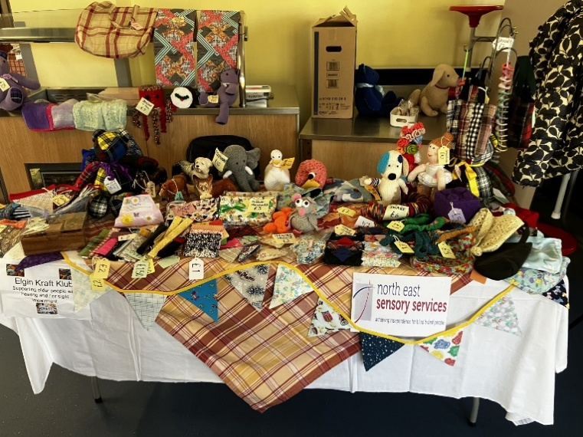
[Image caption: Sales table laid out with a variety of craft goods for sale, all made by the Elgin craft group, including knitted toys, cloth bunting, and a variety of bags and purses in brightly coloured and patterned materials.]

Keeping connected in Moray

Our ICT officer, Ryan Leslie, continues to be available if you would like to find out more about technology and how it could help you day-to-day. Many people have been interested in finding out about the Meta Ray-Ban glasses mentioned in the last NESS News, with regular queries about using smartphones and electronic magnifiers, but Ryan can advise about all sorts of technology! With the recent changes in Moray, Ryan will visit you at home. If you’d like to find out more about how technology can make your life easier, please get in touch by phoning or emailing NESS reception, who will put you in touch with Ryan.

NESS CONTACT INFORMATION
www.nesensoryservices.org
www.facebook.com/northeastsensoryservices
Duty workers can be contacted by telephone, SMS, or email. Deaf BSL users can contact us using ContactScotland BSL.

ABERDEEN
21 John Street, Aberdeen, AB25 1BT
Duty Worker available Monday to Friday from 2-4pm
Tel: 0345 271 2345
SMS: 07593 102004
Email: aberdeenduty@nesensoryservices.org

DUNDEE
Number Ten, 10 Constitution Road, Dundee, DD1 1LL
Duty Worker available from Monday, Wednesday and Friday from 2-4pm
Tel: 01382 721455
SMS: 07713 711772
Email: dundeeduty@nesensoryservices.org

ANGUS
No office-based appointments available but please get in touch
Tuesday 2-4pm and Thursday 2-4pm
Tel: 0345 271 2345
SMS: 07593 102004
Email: angusduty@nesensoryservices.org

MORAY

For Moray based services, please contact the Aberdeen Office
Tel: 0345 271 2345
SMS: 07593 102004
Email: info@nesensoryservices.org

ASPC Advert

