NESS NEWS
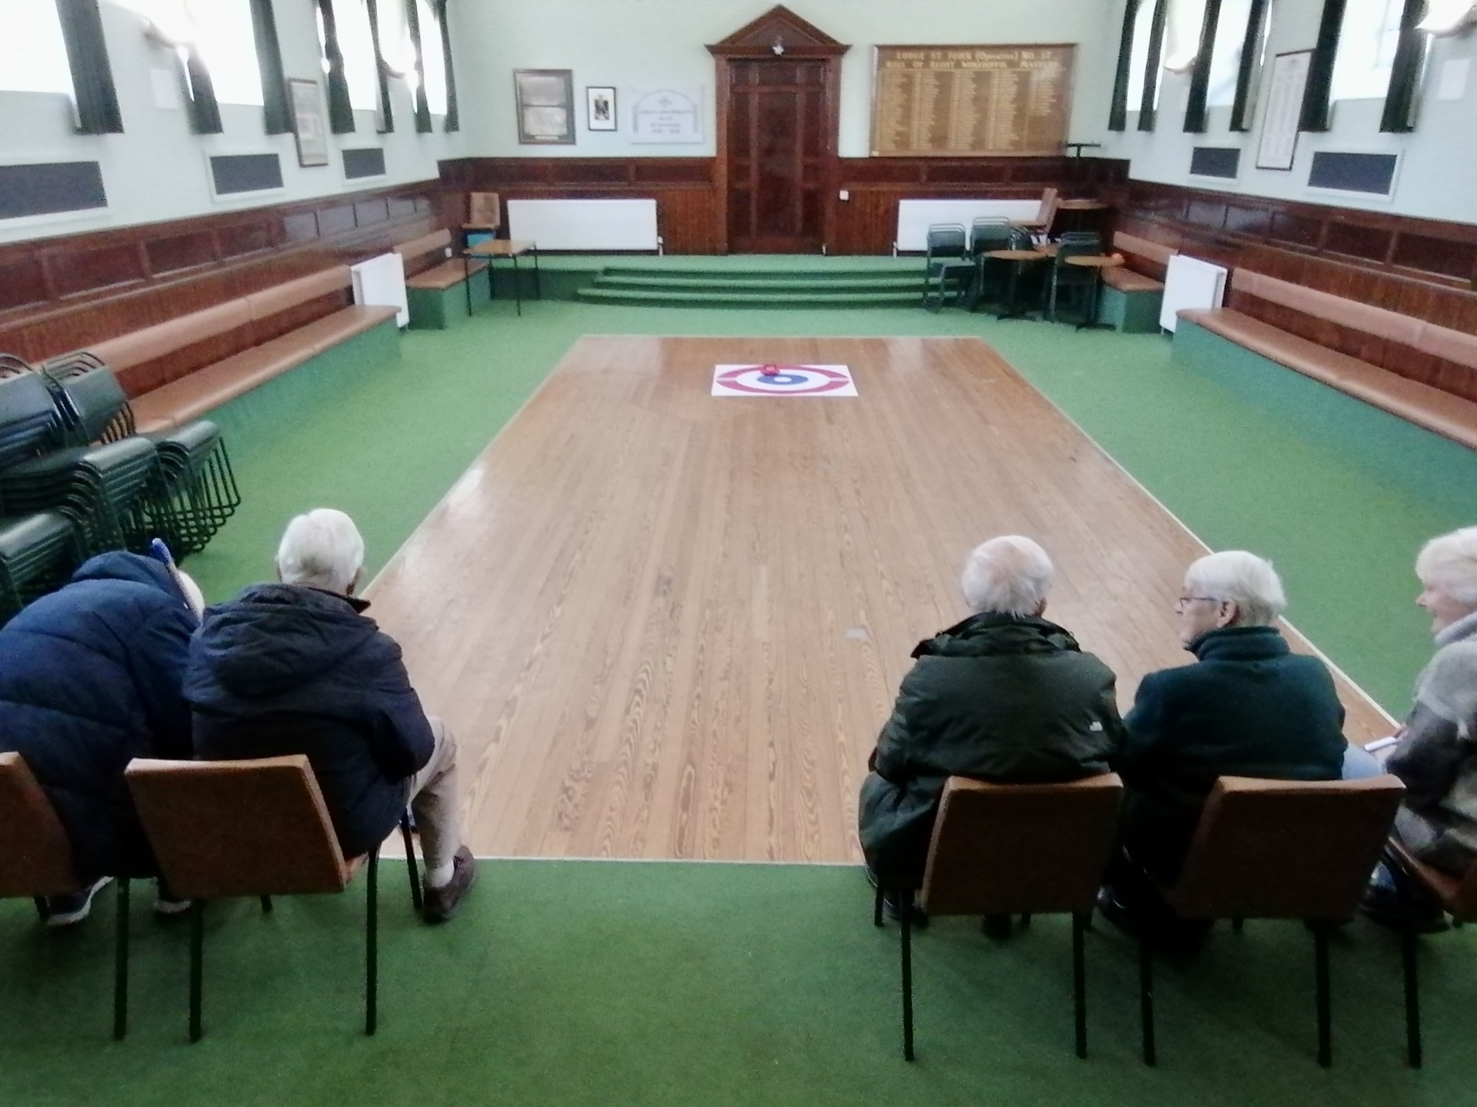

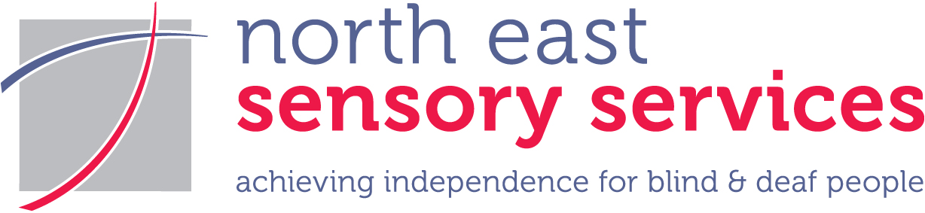

Spring 2026
North East Sensory Services Newsletter
www.nesensoryservices.org

Contents
Contents 2
Did you know? 3
“I’m no longer in the doldrums” - Ethna’s story 3
Can you help us raise awareness? 5
Meta Ray-Ban – making life much easier! 5
Contact Scotland BSL has a new provider 6
BSL access to booking your driving test 7
Could you switch to digital? 7
Half-term fun for our YPSS youngsters 8
Welcome to our new NESS staff 9
Congratulations to NESS staff on their long service awards 11
New NESS telephone system 12
Aberdeen News 12
Congratulations to Blind Bowling champions! 12
Choose us as your Co-op Local Community Cause! 13
Moray News 14
Veterans Visit by Buckie Sensory Group 14
Thank you for voting for NESS at Tesco Extra, Elgin! 14
NESS CONTACT INFORMATION 15
ABERDEEN 15
DUNDEE 15
MORAY 15
ANGUS 15

This magazine is available in large print (pt. 14), jumbo print (pt. 24), braille, CD, email, BSL DVD, and BSL YouTube video: www.youtube.com/@BSLNESS/playlists. If you are able to receive this newsletter by email, please let us know and help us save postage and paper. If you have not received this in your desired format or do not wish to receive it at all, please contact us so that we can change our records accordingly. Charity Registered in Scotland SC009537 Company Limited by Guarantee SC155630. All views expressed in the newsletter are the views of individual contributors and do not necessarily reflect the view of North East Sensory Services.

Did you know?

“I’m no longer in the doldrums” - Ethna’s story

Ethna Taylor, 70, shares her experiences of sight loss, and how much she has benefited from the support provided by NESS. Having recently retired from her job as a shop assistant, Ethna woke up one morning in 2020 to find that she could not see anything out of her left eye.
Having experienced headaches and a sore neck, she was later diagnosed with giant cell arteritis, an inflammatory disease which often affects the arteries at the side of the head. The condition sometimes results in a reduction in the blood supply to the eyes, leading to blurred vision or blindness. In Ethna’s case, only her left eye was affected by the disease, but she already had poor vision in her right eye caused by having a lazy eye.

As she tried to adjust to being partially sighted, Ethna became increasingly anxious about leaving her house, only venturing outside with her husband or a close friend. However, she regained her confidence with support from NESS’s Vision Rehabilitation specialist, who provided crucial support, guidance and training.

Ethna explains further, “I woke up one Saturday morning, and I couldn't see out of my left eye. It was really scary. When I first woke up, I thought I was still sleeping. I said to my husband, ‘I can't see out of that eye’. He wiggled his fingers in front of me, but I couldn’t see them. My left eye used to be my good eye. My right eye is a lazy eye, which means I don’t see well out of it. My husband was working on the Monday (that day), so I had to travel to the eye clinic in Aberdeen myself on the bus. Having one eye not seeing at all and the other not seeing well, it was terrifying.”

Her condition resulted in Ethna losing aspects of her independence, such as being unable to drive, finding it difficult to judge distances, and bumping into people.

Things changed for Ethna in 2022, when her optician put her in touch with NESS. She was assigned a Vision Rehabilitation Specialist (or rehab worker), who helped her adapt her life to her sight loss.

She said: “If he hadn’t put me in touch with NESS, I would still be in the doldrums. I’m going out on my own now, but before I got in touch with NESS, I wouldn’t go out myself. I went out once a week with my friend, who always stood at my blind side, knowing that I’d bump into her. The only other time I went out was with my husband.”
As well as giving her tips around the house, such as using extra lighting and getting low vision magnifiers to help with reading, the rehab worker also taught her how to use a cane.

Ethna said: “When I first started learning, they gave me a small symbol cane. You use it when you go out to tell people to give you a bit of space, that you don’t see so well. But I would still bump into people, so we tried a few canes until I got the one I’ve got now, which is a long cane with a roller ball on the end. The rehab worker showed me how to use it, and I think this one is better because everybody can see it as I move it across in front of me. I felt when I was using the smaller symbol cane, people were ignoring it – folk walk about with their faces in their phones a lot.

“The rehab worker taught me to walk in the middle of the pavement, so that people coming out of shops don’t crash into me. It’s important that people give me a bit of space. Using the cane, I’m not apprehensive anymore, I’m confident going out and on the bus.”

The rehabilitation worker also noticed that while she was crossing the road, Ethna was having trouble hearing traffic, and suggested she have her ears tested. As a result, she now wears hearing aids, which have also had a positive impact on her daily life. She now regularly visits the gym and goes swimming.

She said: “If it wasn’t for NESS, I don’t know where I would be. I wouldn’t be going out on my own. NESS gave me the tools and the confidence, and a great rehab worker. I say to anyone with sight loss: find someone that you like that you get on with and go from there.”

We would like to thank Ethna for sharing her experiences of sight loss. Ethna’s story show how scary and bewildering it can be to lose your sight. With the right emotional support, along with learning practical strategies, Ethna has been able to adapt and get used to her new situation.

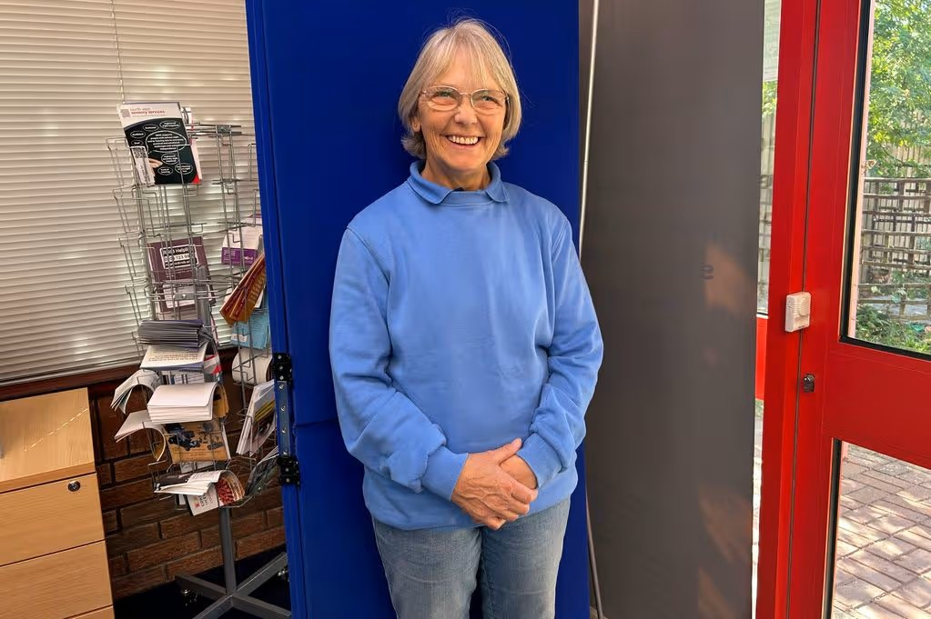
[Image caption: Ethna smiles while standing in front of a blue background, with a leaflet holder in the background]

Can you help us raise awareness?

Personal stories, like Ethna’s, are really important in helping NESS to raise awareness of sight loss, hearing loss, Deafness and deafblindness, as well as to tell people about what NESS does. We need your help to continue to raise awareness and highlight the impacts of sensory loss, educate the public about the things that make a difference to people’s lives and hopefully reduce some of the day-to-day barriers. By sharing your story, you also help us to reach out to funders and encourage people to support NESS by fundraising for us.
We are always on the lookout for personal stories. You story could be about your experiences of sensory loss, or about something you learned or achieved, a tool, a technique or piece of technology that you found particularly helpful in being able to go about your daily life.
If you are comfortable doing so, personal stories can be shared in the press, which is a great way to reach new people and tell them about sensory loss and about NESS. If you would rather, your story can be shared within NESS as part of our training or in NESS News, whatever you are most comfortable with. You can choose where to share your story and how widely.
To date, people have shared their personal stories in written format. We would like to introduce video formats as well, but the choice would remain yours which you would prefer to do.
We always appreciate people sharing their experiences, and people who have shared their stories with us have enjoyed the process. If you decide that you would like to share your personal experiences of sensory loss to help NESS raise awareness, either in video or print format, we will guide and support you through the process.
If you would like to get involved, please get in touch with us in any of the usual ways.

Meta Ray-Ban – making life much easier!

The Meta Ray-Ban smart glasses are the latest mainstream tech to benefit visually impaired people. These high-tech glasses connect to an app on your smart phone, allowing you to control them by speech.
Meta Ray-Ban glasses can help you to access lots of things, for example, they can read menus or signs. They can even describe a scene, so you can find your way around - just say, “Hey, Meta, look and read,” or “Hey, Meta, what am I looking at?”
Like many mobile accessories, you can send messages or make phone calls with them. They are simple to use but have a lot of functionality.
Kevin, one of our ICT Officers, uses the Meta Ray-Ban glasses regularly. He says, “I use my personal pair for reading bus signs and identifying shops.”
If you would like more information or a demo, please get in touch with Kevin or Ryan, our ICT Officers. They are happy to help and are able to demonstrate how the Meta Ray-Ban glasses work.
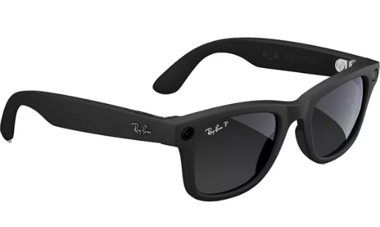

[Image caption: a pair of Meta Ray-Ban glasses]

Contact Scotland BSL has a new provider

As of December 2025, Contact Scotland BSL is being provided by Sign Solutions. The information on the website has been refreshed, but the way to use Contact Scotland BSL is much the same as it was. It continues to be available all day, every day, and can be used to contact any public, private or third sector organisation e.g. to make an appointment. You can also use it to contact NESS.
The website has videos which show how to use Contact Scotland BSL as a Deaf person contacting a hearing person, and as a hearing person contacting a Deaf person.
For more information about how Contact Scotland BSL works, you can visit their Frequently Asked Questions (FAQ) https://contactscotland-bsl.org/faqs/pages which contains a series of BSL videos explaining all aspects of the service.
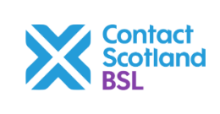
[Image caption: the Contact Scotland BSL logo]

BSL access to booking your driving test

The Driver Vehicles and Standards Agency (DVSA) recently started using Signly, a BSL translation tool integrated into the website, making the booking process for driving tests more accessible to Deaf learner drivers. So far, the DVSA is the only government department that includes BSL access to its booking service.
For the past few years, Deaf learner drivers have had BSL videos incorporated into the theory test, and Deaf learner drivers can book a BSL interpreter for the theory test, making it accessible. BSL interpreters are the only language interpreters allowed during the practical driving test. People with hearing loss can also ask for loop systems or a lip speaker to help them access their driving test.
Adding Signly is another step to improving the accessibility of driving tests for Deaf learner drivers.
For more information about the accessibility of driving tests, visit Theory test: cars: If you have a reading difficulty, disability or health condition - GOV.UK

Could you switch to digital?

Did you know that you can receive the NESS News in a variety of formats? You can receive it in Braille, large print (size 16 font), or jumbo print (size 24 font). We can email it out to you – we usually send it in PDF format and can also email it as a Word document.
We can also send it out in audio format, recorded on to a CD, and in BSL video recorded on to a DVD. We also have a BSL YouTube playlist, which has all of our BSL versions of the NESS News. Here is the link to the BSL YouTube channel www.youtube.com/@BSLNESS/playlists.
You can also sign up on our website to receive a mailed newsletter version direct to your email inbox. Just go to the front page of our website and scroll down until you see the sign-up box.
As the price of printing and postage continue to be a challenge, we are looking at ways that we can manage these costs by increasing the availability of digital versions of NESS News.
We know that many people now prefer to receive digital information, and a number have already made the change to a digital NESS News, for which we are very grateful. If you are able to, we would encourage you to consider receiving the NESS News digitally. Every switch from a paper copy helps us to reduce the costs and the environmental impact. Please get in touch in any of the usual ways if you would like to change how you receive the NESS News.
You will continue to receive your print, Braille, audio CD, and BSL DVD version unless you tell us you would like to receive a digital copy.

Half-term fun for our YPSS youngsters

The youngsters from our Young People's Sensory Service (YPSS) had a great time, as ever, during the February half-term holidays. Our Aberdeen City and Shire group enjoyed their annual visit to Spectra, Scotland's Festival of Light, which brightens up Aberdeen city centre each year with stunning art installations using light and sound. It was needed more than ever with the gloomy weather and brought smiles to everyone's faces. Wrapped up warmly, our young people enjoyed the toasty fire displays in Union Terrace Gardens, the beautiful, illuminated animals in Marischal Square, and much more.
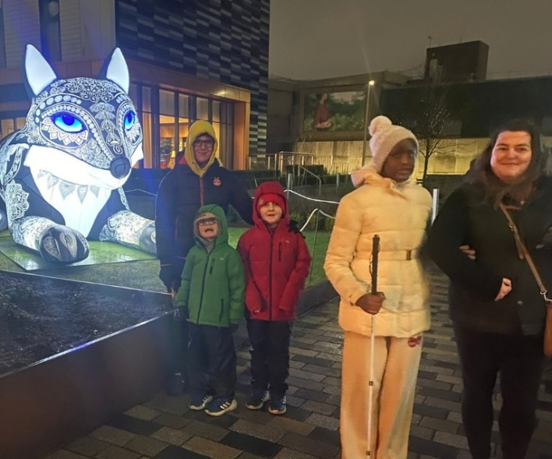

[Image caption: A group of warmly dressed youngsters stand in front of an illuminated fox sculpure during the Spectra Festival.]

Our Angus and Dundee groups dodged the weather and had a great time ten pin bowling and trampolining – both of which encourage friendly, healthy competition and help develop physical confidence and spatial awareness. They are also lots of fun! Meanwhile, our Moray group enjoyed trying out indoor versions of games including curling and miniature axe throwing, which build coordination, flexibility and communication skills.

These are just a very small selection of the wide range of activities which our children and young people enjoy throughout the year. Our YPSS enables them to enjoy experiences which may otherwise be hard to access, to develop skills and interests, and to meet and make friends with other youngsters.

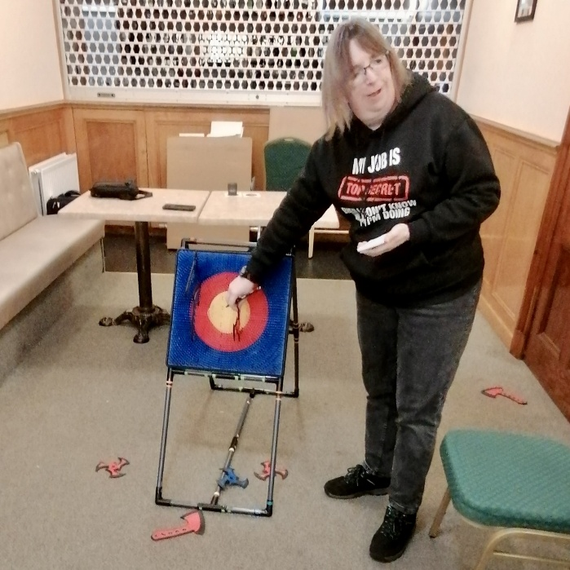
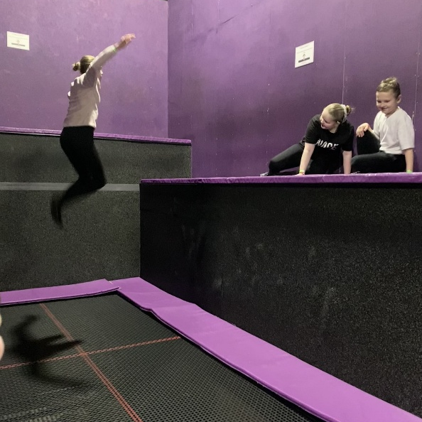

[Image caption: NESS’s Heather Roy stands next to the indoor “knife throwing” target, checking the scores.]
[Image caption: A girl bounces high on a trampoline, while a girl and boy watch, smiling, from the side.]

Welcome to our new NESS staff

Ames Gregor joined NESS in late 2025, working across projects and service support with a focus on systems, coordination, and practical problem-solving. A self-described tech geek, Ames brings an established career in digital technology and product development and helps translate technical discussions into clear, workable decisions, supporting improvements to day-to-day operations and efficiency.
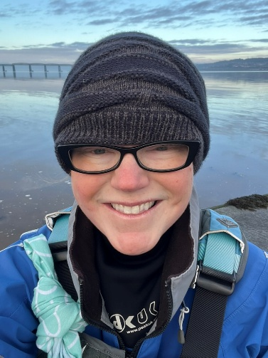
Ames is currently studying for an MSc in Counselling. Outside of work, Ames is a keen swimmer and sea-kayaker, and volunteers as a trainee crew member with the RNLI and with local community initiatives. Ames says, “Looking forward to meeting everyone and working with the super team at NESS!"
[Image caption: Ames Gregor, wearing a wooly hat and glasses, stands in front of a river.]

Emma Welsh joined NESS in November 2025 as Community and Partnerships Coordinator. Emma works across events, corporate engagement and community initiatives, helping to build meaningful relationships that raise both awareness and vital funds to support people with vision and hearing loss.

With a background in law and operations, Emma brings strong organisational skills, creativity and a passion for connecting people. She is driven by inclusion and accessibility, both professionally and personally. As a mum to two boys, one of whom has a visual impairment, Emma has experienced first-hand the importance of advocacy and community support.

Outside of work, Emma is a committed advocate for inclusion within her local community. She serves on her local school Parent Council and runs a local online support group for parents of newly diagnosed children with sight loss. In her downtime, Emma enjoys traveling, hiking, spending time with family and friends and continuing her brave campaign to convert friends and family into country music fans.

Emma says, “I’m proud to be part of the NESS family and support work that genuinely makes a difference.”

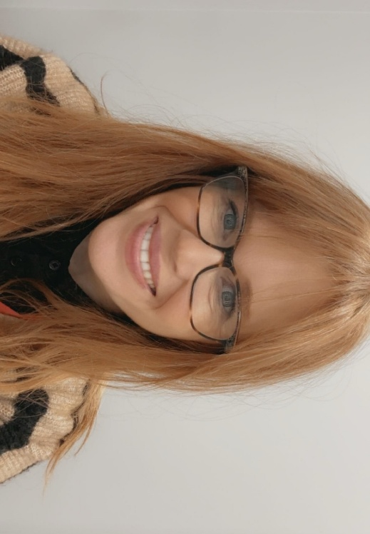

[Image caption: Emma Welsh, smiling]

Shruti Kudtarkar joined NESS in January 2026, with a remit of supporting the Fundraising Team and to promote the NESS lottery.

Shruti says, “Hi, I’m Shruti. I moved to the UK from India to do my Masters in Media and Communications, and somehow ended up here, which I’m very happy and grateful about.

“I come from a PR and social media background, so I’m excited to put that to use for NESS and the meaningful work we do here. When I’m not working, you’ll find me lost in books, colours or sunsets. Looking forward to growing, learning, and laughing with all of you.”


[Image caption – Shruti wearing a blue and white dress with a lake and hills in the background]

Congratulations to NESS staff on their long service awards

Our staff are our greatest asset, enabling us to deliver our vital services and support. We were delighted to see six members of staff receive long service awards at our Full Staff Meeting in December.

Receiving awards for 20 Years’ Service were Andrea Bryant (PA and Finance Assistant) and Andrew Douglas (Transcription Co-ordinator). Awards for 10 Years’ Service went to Selina Edward (Administration Assistant, Reader and Driver), Dawn Maclean (Receptionist / Resource Centre Worker), Sheila Ogden (Added Value Services Manager), and Laura Ramsay (Rehabilitation Worker). Congratulations to everyone, and a huge thank you!
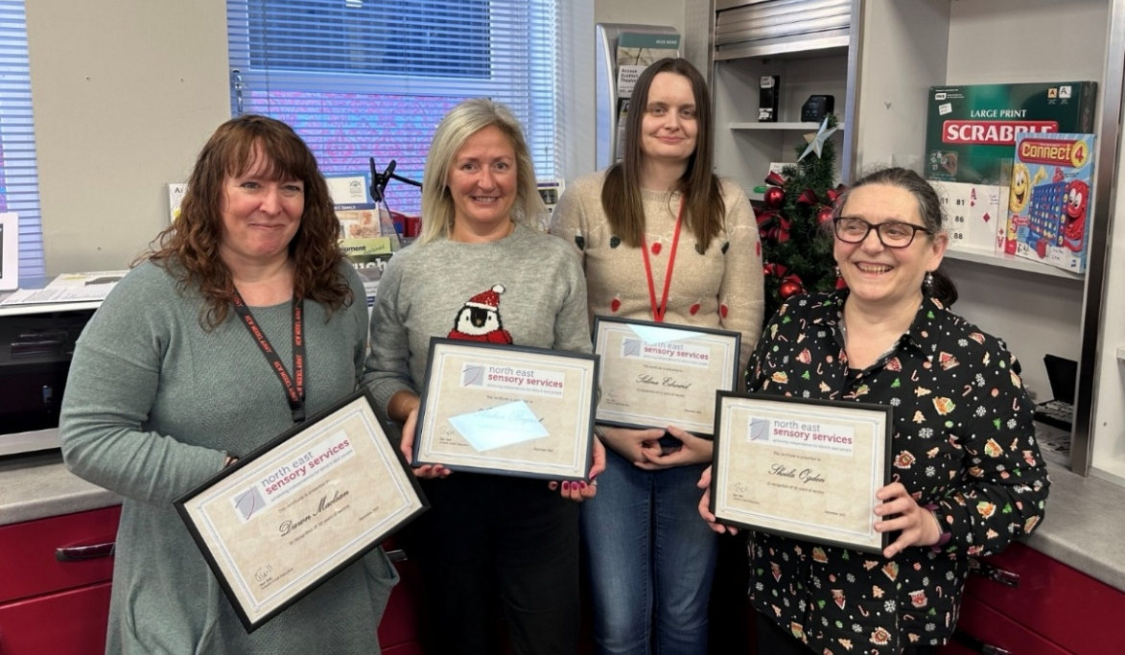

[Image caption: Pictured left to right are Dawn Maclean, Andrea Bryant, Selina Edward and Sheila Ogden, holding their framed Long Service Award certificates]

New NESS telephone system

During the month of April 2026, we will be switching over to a more digital-based telephone system. This should not make any difference to you, our customer. However, if there are any teething issues, please bear with us. Fingers crossed there are none, but (just in case) you can still contact us on the mobile telephone numbers 07593 102004 (Aberdeen & Angus) or 07713 711772 (Dundee) or email on info@nesensoryservices.org.

Aberdeen News

Congratulations to Blind Bowling champions!

Very well done to the following bowlers, who did themselves, Summerhill Blind Bowlers and Aberdeen Indoor Bowling Club proud with their successes over the last year. Huge congratulations from all at NESS!

Betty Morrison and Melanie Finch were Bronze medal winners at their first attempt in the VIBS (Visually Impaired Bowls Scotland) 2024/25 Indoor Open Pairs Competition.

There was success for three members at the Grampian Disability Sport Visually Impaired Lawn Bowls Championships held at Woodend Bowls Club last July. Muriel Milne, at that time Summerhill Blind Bowlers’ newest member, won Gold in the Ladies’ VI category in her first VI competition. David Cox won Silver in the Men’s VI category, and Melanie Finch won Bronze in the Ladies’ VI category.

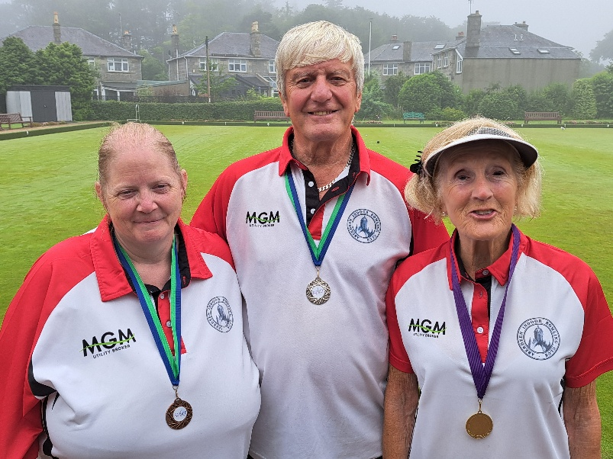

[Image caption: from left to right, Melanie Finch, David Cox and Muriel Milne all wearing their bowling t-shirts and sporting their medals following their successes at the Grampian Disability Sport Visually Impaired Lawn Bowls competition.]

Muriel Milne also won the Morrison Cup at Perth West End Bowling Club in September last year, along with her bowls partner for the day, Brian Carroll of Colgrain Bowling Club, Helensburgh. They competed against visually impaired bowlers from all over Scotland in this annual competition. Betty Morrison, the sponsor of the Morrison Cup, was delighted to see the Cup returning to Aberdeen for six months. It will then be passed to Brian to hold until this year’s competition.

Choose us as your Co-op Local Community Cause!

Did you know that NESS is part of the Co-op Local Community Fund within the Aberdeen area? From now until October this year you can help us receive a share of a £5 million funding pot to support our Young People’s Sensory Service (YPSS) activities in Aberdeen! The amount of funding we receive will be based on the number of Co-op members who choose us as their local community cause – so we need your help!
Co-op Members can choose our cause (listed as Grampian Society for the Blind (NESS)) via the website or on the app. Signing up is easy if you aren’t already a member.
The website link is https://www.coop.co.uk/local-causes
or you can download the Co-op Membership app on your Apple or Android device.
Please note – our cause can only be chosen by those living within 15 miles of Aberdeen City Centre. You may need to alter the radius (to 15 miles) on your profile to see us.
Thank you for your support!


[Image caption: A white ‘Co-op’ logo on a blue background]

Moray News

Veterans Visit by Buckie Sensory Group

After the slow start in January because of the snow and icy conditions, the Buckie Sensory Group enjoyed a visit to the Erskine Veterans Activity Centre in Forres. This followed on from an earlier talk by Erskine to the Buckie Group who wanted to visit the new centre once it was opened. Everyone enjoyed seeing the facilities and celebrated with a coffee and packed lunch.

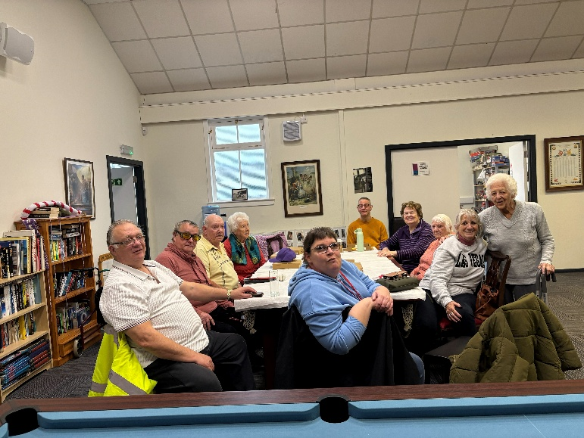

[Image caption: Buckie group members enjoying their coffee and packed lunch at the Erskine Veterans Centre in Forres]

Thank you for voting for NESS at Tesco Extra, Elgin!

A huge NESS thank you to everyone who took the time to vote for NESS in-store at Tesco Extra, Blackfriars Road, Elgin. Watch this space in the next edition of NESS News to find out how much has been awarded to support our Young People’s Sensory Service (YPSS) activities in Moray. As you know, our YPSS supports children and young people living with serious sight and/or hearing loss. Taking part in activities such as horse riding, canoeing, skating and much more helps our youngsters to grow in confidence and independence, make friends and develop their social skills, and foster ambitions for the future – all while having loads of fun. Thank you for helping us to make a difference!

NESS CONTACT INFORMATION
www.nesensoryservices.org
www.facebook.com/northeastsensoryservices
Duty workers can be contacted by telephone, SMS, or email. Deaf BSL users can contact us using ContactScotland BSL.

ABERDEEN
21 John Street, Aberdeen, AB25 1BT
Duty Worker available Monday to Friday from 2-4pm
Tel: 0345 271 2345
SMS: 07593 102004
Email: aberdeenduty@nesensoryservices.org

DUNDEE
Number Ten, 10 Constitution Road, Dundee, DD1 1LL
Duty Worker available from Monday, Wednesday and Friday 2-4pm
Tel: 01382 721455
SMS: 07713 711772
Email: dundeeduty@nesensoryservices.org

ANGUS
No office-based appointments available but please get in touch
Tuesday 2-4pm and Thursday 2-4pm
Tel: 0345 271 2345
SMS: 07593 102004
Email: angusduty@nesensoryservices.org

MORAY
For Moray-based services, please contact the Aberdeen office.
Tel: 0345 271 2345
SMS: 07593 102004
Email: info@nesensoryservices.org

ASPC Advert

