**Community Fundraiser**

**Location: Based in the Aberdeen office with regular travel across Scotland**

**Hours: Full Time 36.25 hours per week**

**Salary: £24,000 - £26,000 (dependent on experience)**

**This post is subject to membership of the PVG scheme**

**Benefits:**

**Pension: 7% employers & 3% employee’s**

**Annual Leave 32 days (includes 5 fixed and 7 floating public holidays)**

**Learning and Development opportunities**

**Employee Assistance Program**



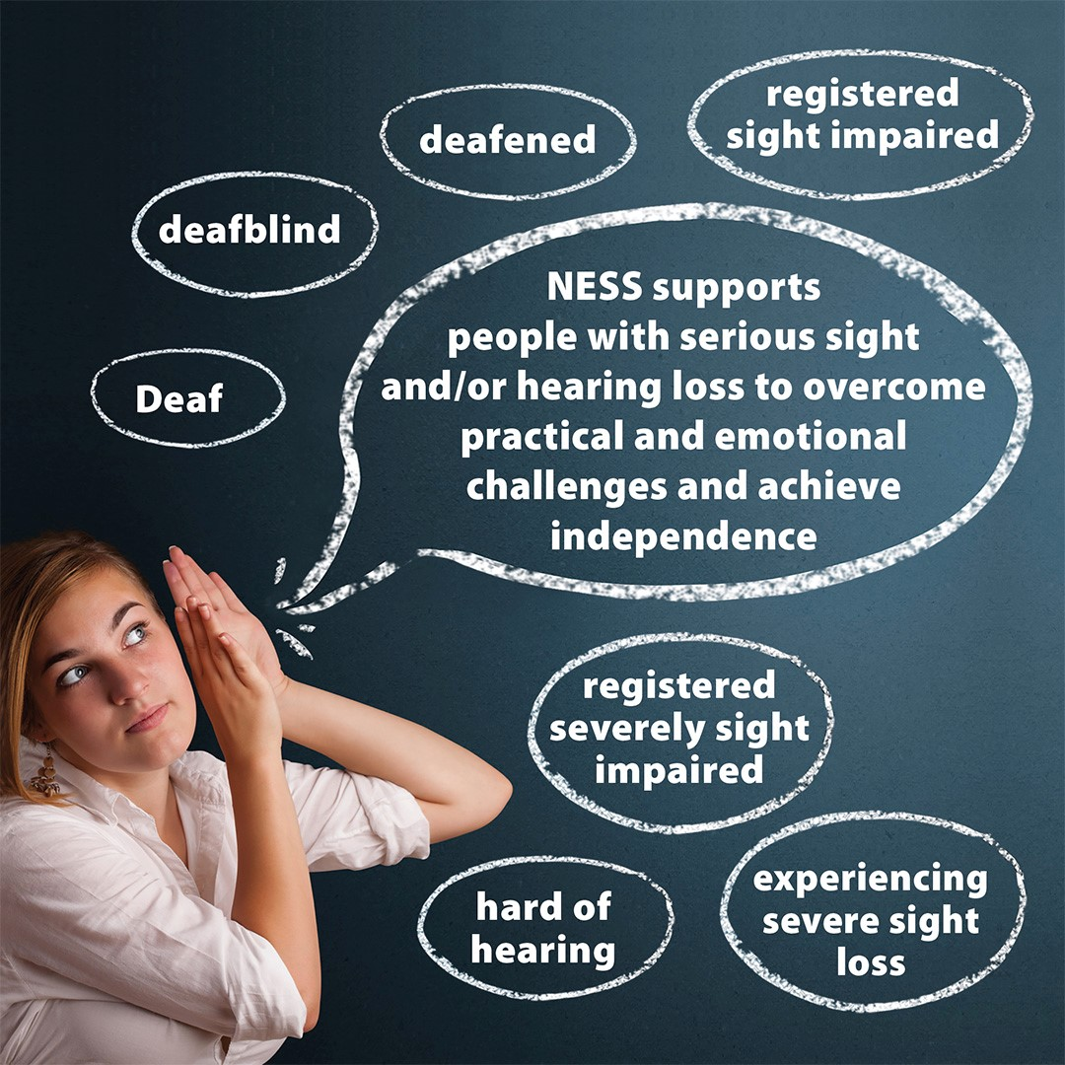

**About NESS Services**

**Our Mission**

Achieving Independence for Blind and Deaf People

**Our Values**

As an organisation, NESS needs to be effective, innovative, and competitive.

Our people work in a way that is professional, flexible and responsive and accountable.

**Our Vision**

A Scotland aware of the needs of people with sensory impairment, that includes them as equal participants in community life and offers them the opportunities available to all

North East Sensory Services (NESS) supports people living with a sensory loss in Aberdeen City, Moray, Angus and Dundee. Everything we do aims to work towards our mission of “achieving independence for blind and deaf people”. All our services are joint sensory services, so our staff support people with a significant sight loss, a hearing loss, sight and hearing loss, who are Deaf BSL users or who are Deafblind.

Living with a sensory loss can bring huge challenges and everyone with a sensory loss will have a different experience, requiring specific information and support. Our job is to provide our service users with the information, advice and support that they need, so that they can live the life they want with their sensory loss.

More information about our services is available on our website [www.nesensoryservices.org](http://www.nesensoryservices.org).

**Our five leadership qualities**

* Capable: being good at what they do
* Committed: to our values
* Connected: being with others within and out with NESS
* Communicating: good at listening and influencing others
* Caring: generous and willing to support others

**About the role**

As a key member of our fundraising team, you will play an integral role in driving community engagement and income generation across the regions. You will:

* Support organisational objectives through developing and nurturing relationships within local communities
* Identify and research opportunities to increase fundraising income as part of fundraising targets set in conjunction with your line manager
* Plan, develop, market and deliver a range of fundraising events which are well-targeted, strategically planned and evaluated. This includes a financial understanding of managing profits and costs within a budget
* Attend community events as required and raising awareness and boosting community engagement and awareness through talks and collecting donations.
* Build long term relationships with supporters through high standards of care.
* Promote a variety of ways for supporters to engage with NESS, including regular direct debits, our lottery, legacies and individual fundraising ideas
* Recruit participants to take part in fundraising challenge events such as the Chapleton Bike Ride, Kiltwalk and Tough Mudder
* Support the creation and delivery of campaigns, information and training designed to attract, support and retain volunteers
* Provide high standards of support to facilitate long-term relationships
* Be person centred and responsive when responding to community fundraising queries
* Support the daily operations of the fundraising team
* Maintain accurate and up to date records on the fundraising data base and action appropriately
* Willing to work in a dog friendly environment
* Willing to learn BSL

**General Responsibilities**

* Continue to develop your skills and knowledge through continuous professional development and supervision
* Work within the wider fundraising and PR team
* Collaborate effectively with colleagues within the organisation and external agencies and partners
* Adhere to NESS policies and procedures as described in the Staff handbook, including HR, organisational and health and safety
* Maintain confidentiality regarding sensitive information related to staff, service users, volunteers, supporters and partner organisations
* To undertake other such duties as may be reasonably required by the organisation
* Be prepared to travel independently

**About you**

* Have previous experience of fundraising and event management
* Be an excellent relationship builder with good interpersonal skills who is able to persuade, influence and secure commitment from others
* Be self-motivated with a commitment to excellence and a proactive, flexible approach to work
* Demonstrate effective time management and the ability to problem solve and priorities while working to meet multiple deadlines
* Able to work effectively as part of a team as well as independently
* Ability to communicate well and be confident in presenting to a variety of audiences
* Be a member of, or join, the institute of fundraising
* Understand and follow current fundraising regulations and best practice
* Demonstrate a commitment to delivering excellence and to driving and implementing continuous improvement practices
* Be willing to work evenings and weekends when necessary

**Application**

To apply please complete the attached application form outlining your suitability for the role, your experience in events fundraising, and your motivation for applying to Pam Smith, Support Services Manager, at [pam.smith@nesensoryservices.org](mailto:pam.smith@nesensoryservices.org)

We advise you to refer to the ‘About you’ section and use this to explain your suitability for the role in your application. The more you can relate your skills and experience to this role, the higher the likelihood of progressing to the interview.

To find out more about the role you can also contact Pam Smith, Support Services Manager with any questions.

**Application deadline is Wednesday 25th June 2025 at 12 noon.**

**Interviews**

Interviews will take place at our head office in Aberdeen. You will be asked to give a 5-10 minute presentation related to the role and this will be followed by questions linked to the role and responsibilities listed.

**Interviews will take place on Monday 7th July 2025**.