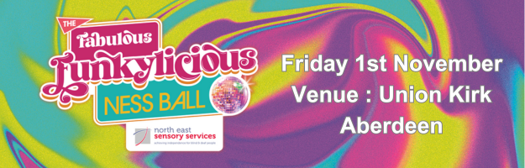

Platinum VIP Sponsors x 1 = £5,000
As the top sponsor of our NESS Fabulous Funkylicious Ball you will help make this event a hugely enjoyable and memorable experience for all.

For this the sponsor will receive –
- Entry to an exclusive VIP – pre-dinner entertainment & drinks reception x 2 tables (20 people)
- Each table of 10 includes wine (2 red/2 white) plus 1 x bucket of beers.
- Full accreditation + Full-page ad, plus logo on front of programme
- A rolling ad on screen displays
----------------------------------------------------------------------------------
Gold sponsor – Fabulous Funkylicious Drinks Reception - £3,000
As the sponsor of our Welcome Drinks, you will help NESS kick start this event off in style.

- A table of 10 including wine (2 red/ 2 white) plus 1 x bucket of beers
- Full accreditation + Full-page ad in the programme
- A rolling ad on screen displays
------------------------------------------------------------------------------------
Silver Sponsor – Fabulous Funkylicious Creative Sponsor £2,000 (2 packages – 1 available other has been sold)
As one of the Creative Sponsors of our event you will play a big part in helping to recreate the 70s/80s vibe ensuring our guests have an amazing evening.

- For this the sponsor will receive -
- A table of 10 including wine (1 red/ 1 white) plus 1 x bucket of beers
- Full accreditation + Half-page ad in the programme
- A rolling ad on screen displays
--------------------------------------------------------------------------------------
Bronze Sponsor – Fabulous Funkylicious Design & Advertising Sponsor £1,500
As the Design & Advertising Sponsor you will help us cover the costs of our high-quality eye-catching design and printing costs for this event. We have secured the services of Gavin Fraser, a local graphic designer.

- A table of 10 including wine (1 red/1 white)
- Full accreditation + Half page ad in the programme
- A rolling ad on screen displays

All sponsors will have their logo displayed on our website and social media sites as we promote the event.

