NORTH EAST SENSORY SERVICES (NESS)
Media report

April 2022 – March 2023

April 2022

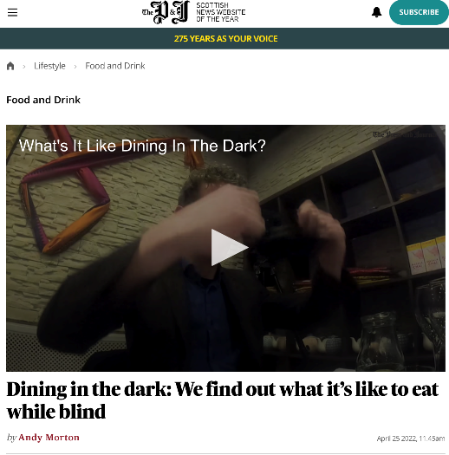
- Dining in the Dark: We find out what it’s like to eat while blind
Press and Journal journalist Andy Morton was invited to Aberdeen’s Namaste Delhi to try a Dine in the Dark evening, which was organised by NESS. The event aims to give small insight into the challenges faced by those with sensory loss and sees diners spending the meal completely blindfolded. Writing about his experience, Morton acknowledged the difficulties, describing it as ‘draining’. He also quoted the experiences of others who joined him.
Online coverage, which includes a video from the event, can be found here: https://www.pressandjournal.co.uk/fp/lifestyle/food-and-drink/4204361/ness-dining-in-dark-aberdeen/
This story was also picked up in print by the Press and Journal and Aberdeen Evening Express.

- North-east charity's fundraising ball to feature Paralympic heroes

A news story about Neil and Lora Fachie’s appearance as star guests at the NESS Sensational Sensory Ball was published by Grampian Online: https://www.grampianonline.co.uk/news/north-east-charitys-fundraising-ball-to-feature-paralympic-271577/

This story was also picked up in print by the Aberdeen Evening Express.

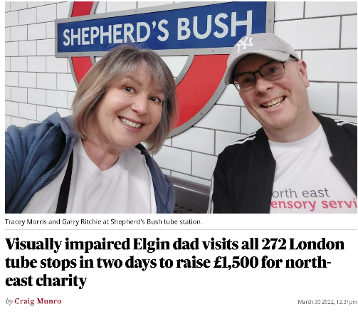
- Visually impaired Elgin dad visits all 262 London tube stops in two days to raise £1,500 for north-east charity

In March 2022, visually impaired NESS service user Garry Ritchie took on the London ‘Tube Challenge’, visiting all 262 stops with his sighted guide. The challenge took 25 hours over two days and Garry raised £1,800 for the charity.
Online coverage of Garry’s challenge can be found here: https://www.pressandjournal.co.uk/fp/news/moray/4112444/ness-tube-challenge-elgin/
This story was also used in print by the Press and Journal and Aberdeen Evening Express.

May 2022

Blind Aberdeen student uses Scottish youth parliament role to ‘break down barriers and increase inclusion’

An interview with blind MYSP Eilidh Morrison, who has received support from NESS, was used by the Press and Journal and Aberdeen Evening Express in print and online: https://www.pressandjournal.co.uk/fp/news/aberdeen-aberdeenshire/4272239/blind-aberdeen-student-scottish-youth-parliament/

Aberdeen businesses step in to support ‘vital’ upcoming north-east charity ball

NESS thanked Aberdeen businesses after they announced they would sponsor the organisation’s Sensational Sensory Ball: https://www.aberdeenlive.news/whats-on/aberdeen-businesses-step-support-vital-7038215

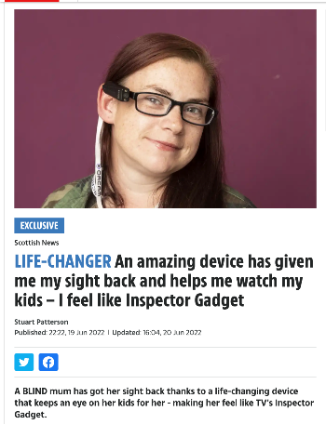
June 2022
- Life-Changer - An Amazing Device has given me my sight back and helps me watch the kids
A story about visually impaired mum Jolene Whyte being given an OrCam MyEye device by NESS was given prominent full-page coverage in The Scottish Sun print edition and online. It was also in print and online by the Press and Journal and Aberdeen Evening Express, online by Aberdeen Live, and by sector press:
https://www.thesun.co.uk/news/scottish-news/18940063/mum-aberdeen-blind/
https://www.pressandjournal.co.uk/fp/news/aberdeen-aberdeenshire/4436079/blind-aberdeen-mum-orcam-myeye-north-east-charity/
https://www.aop.org.uk/ot/industry/charity/2022/06/28/blind-woman-given
https://www.opticianonline.net/content/news/blind-mum-given-life-changing-device/
https://www.aberdeenlive.news/news/health/blind-mum-two-shares-delight-7230199

August 2022
- North-East cyclists encouraged to take part in charity bike ride
Press release on the annual Chapelton Bike Ride: https://www.grampianonline.co.uk/news/north-east-cyclists-encouraged-to-take-part-in-charity-bike-285104/

September 2022
- Dundee social worker takes up management post at sensory charity
News of Carla Marchbank’s promotion to the NESS senior leadership team: https://www.charitytoday.co.uk/dundee-social-worker-takes-up-management-post-at-sensory-charity/

- ‘North-east charity reaches Investors in People Awards Final
Press release on NESS making the final shortlist for a top business accolade at the Investors in People Awards 2022: https://www.grampianonline.co.uk/news/north-east-charity-reaches-investors-in-people-awards-final-288646/

October 2022
- Chapelton Bike Ride raises a ‘brilliant’ £40,000 for local charity
Press release on the success of the Chapelton Bike Ride, which has raised £40,000 for NESS over the past six years:
https://www.grampianonline.co.uk/news/north-east-cycling-event-supports-work-of-sensory-loss-chari-289315/ https://www.scotsman.com/news/people/chapelton-bike-ride-raises-a-brilliant-ps40000-for-local-charity-3867818
This story was also used in print by the Press and Journal and Aberdeen Evening Express.

- NESS lipreading classes
Press release on the launch of new lipreading classes in Aberdeen
https://www.grampianonline.co.uk/news/north-east-charity-launches-new-lipreading-classes-for-peopl-289740/
This story was also used in print by the Press and Journal and Aberdeen Evening Express.

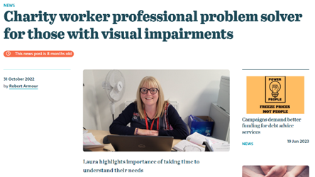
Meet the ‘professional problem-solver’ Carnoustie mum helping those with sight loss back on their feet

An interview with NESS rehabilitation worker Laura Ramsay was used by The Courier in print and online, and by Third Force News:

https://tfn.scot/news/charity-worker-professional-problem-solver-for-those-with-visual-impairments

https://www.thecourier.co.uk/fp/lifestyle/health-wellbeing/3826549/north-east-sensory-services/

November 2022
- North-east Scotland charity launches fundraising calendar
Press release on the NESS fundraising calendar, featuring images by Caroline Rutherford: https://www.visionary.org.uk/latest/north-east-scotland-charity-launches-fundraising-calendar/
https://www.northern-scot.co.uk/news/ness-charity-calendar-features-moray-294962/
https://www.charitytoday.co.uk/north-east-charity-launches-fundraising-calendar/
https://www.grampianonline.co.uk/news/ness-charity-calendar-on-sale-294964/
This story was also used in print by the Press and Journal and Aberdeen Evening Express.

December 2022
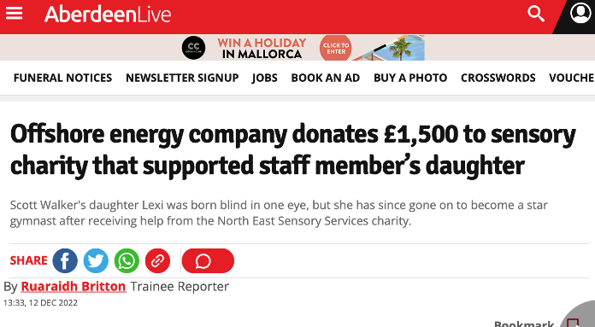
- Offshore energy company donates £1,500 to sensory charity that supported staff member’s daughter
Scott Walker works at a north-east offshore energy company. His daughter Lexi was born blind in one eye and received support from NESS. Scott’s company went on to nominate NESS as its chosen charity for a donation following a team ‘step challenge’.
Online coverage:
https://www.aberdeenlive.news/news/aberdeen-news/offshore-energy-company-donates-1500-7920436
https://www.grampianonline.co.uk/news/company-donates-to-charity-supporting-employees-family-296321/
https://www.pressandjournal.co.uk/fp/news/aberdeen-aberdeenshire/5149288/father-of-visually-impaired-gymnast-raises-funds-for-charity-who-supported-her/
This story was also used in print by the Press and Journal.

January 2023
- Aberdeen fans given the chance to dine with ‘King’ Joe Harper at special charity event https://www.aberdeenlive.news/news/aberdeen-news/aberdeen-fans-given-chance-dine-8027850 https://www.aberdeenlive.news/news/aberdeen-news/dine-dons-charity-event-hailed-8269301
https://www.pressandjournal.co.uk/fp/news/aberdeen-aberdeenshire/5278855/football-supporters-dine-with-dons-north-east-scotland-charity-ness/
https://www.originalfm.com/calendar/event/north-east-sensory-services-ness-dine-with-the-dons-charity-lunch/
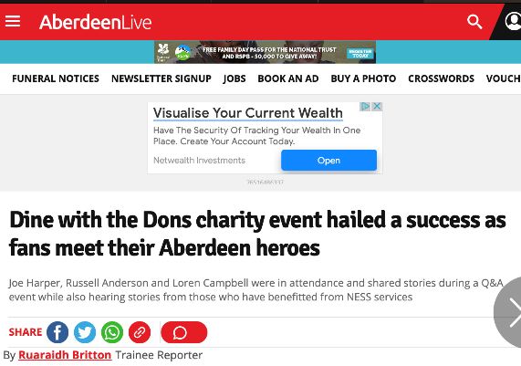
This story was also covered in the print editions of the Press and Journal and Aberdeen Evening Express.

- Living Wage backing
Press release on support from NESS for Aberdeen to become a ‘Living Wage’ city was used in print in the Aberdeen Evening Express, and online: https://www.charitytoday.co.uk/north-east-charity-backs-campaign-to-make-aberdeen-a-living-wage-city/

February 2023
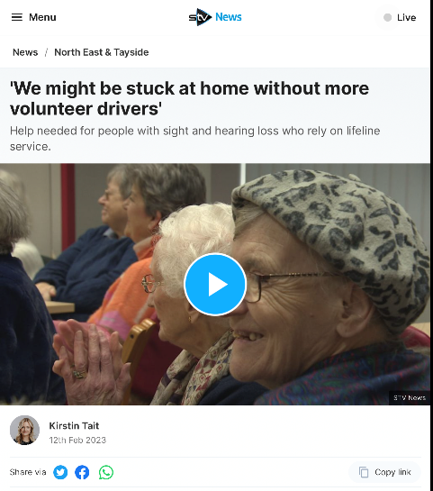
- ‘We might be stuck at home without more volunteer drivers’
In February 2023, NESS launched a campaign looking for new volunteer drivers in all of the areas in which it operates. The charity highlighted the negative impact the shortage of drivers was having on its service users, who were unable to attend social groups and activities and were in some cases being left isolated and household.
This campaign received prominent media coverage, with a package appearing on STV News in Aberdeen, as well as print and online coverage:
https://news.stv.tv/north/north-east-sensory-services-in-aberdeen-needs-drivers-for-people-with-sight-and-hearing-loss
https://www.forres-gazette.co.uk/news/shortage-of-moray-volunteers-having-devastating-impact-on-302627
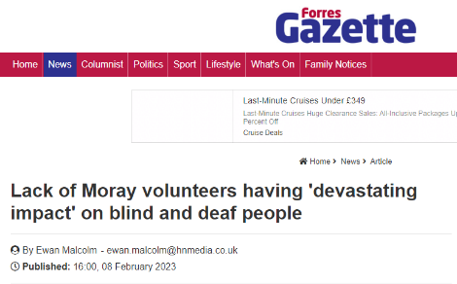
https://tfn.scot/news/shortage-of-volunteer-drivers-has-devastating-impact-on-blind-and-deaf-people-in-aberdeen
https://www.charitytoday.co.uk/shortage-of-volunteer-drivers-has-devastating-impact-on-blind-and-deaf-people-in-aberdeen/
https://www.northern-scot.co.uk/news/we-are-in-dire-need-shortage-of-moray-volunteers-having-302624/
This story was also used in the print editions of The Courier, Press and Journal, Dundee Evening Telegraph and Aberdeen Evening Express.

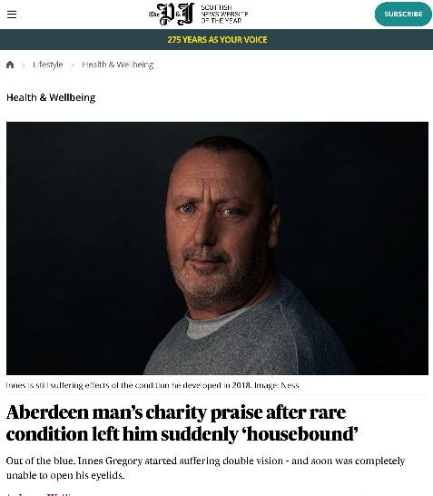
- Aberdeen man’s charity praise after rare condition left him suddenly ‘housebound’
Press release on the PR video donated by service user Innes Gregory, as a gift to say thank you to NESS for him helping to turn his life around. This story was used in print in the Press and Journal and Aberdeen Evening Express, and online:
https://www.pressandjournal.co.uk/fp/lifestyle/health-and-wellbeing/5356432/ness-omg/
https://www.charitytoday.co.uk/north-east-man-with-rare-condition-thanks-charity-through-video-promo-donation/

March 2023
- Dancing gran, 84, raises £10K for north-east charity
A story about NESS supporter Dot Bremner raising a combined £10,000 through her ‘dancercise’ classes and fundraising efforts was given prominent coverage in the Press and Journal and Aberdeen Evening Express, and was used online:
https://www.pressandjournal.co.uk/fp/news/moray/5469298/dot-bremner-ness-blind-charity-elgin/
https://www.northern-scot.co.uk/news/dancing-elgin-gran-raises-over-10-000-for-charity-305693/
https://www.charitytoday.co.uk/dancing-gran-84-raises-10k-for-north-east-charity/
