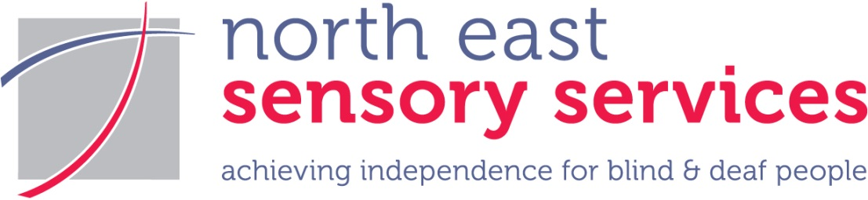

**Tips for communicating with someone who is Deaf or hard of hearing**

These tips will help you communicate with someone who is Deaf or hard of hearing.

* Face the person you are speaking to
* Make sure your face is well lit – don’t sit with your back to the light
* Stop what you are doing
* Speak normally – speaking slowly or shouting distorts your face
* If someone is wearing a hearing aid, ask if they would like to use the loop system
* Move to a quieter place or try and reduce the background noise
* Be aware of echo – rooms with soft furnishings minimise echo
* Use facial expressions and hand gestures
* If the person keeps asking you to repeat what you are saying, try rephrasing it
* Tell them the topic that you are talking about e.g. let’s talk about the price
* Use short sentences and keep to the point
* Be patient and allow extra time
* Write things down in plain English or draw pictures
* Give it a try and never walk away saying “Oh it doesn’t matter”

**BRITISH SIGN LANGUAGE (BSL)**

British Sign Language (BSL) is a language in its own right. It is a visual language using gesture, facial expression, and body movement to communicate. BSL is very different from English, with its own structure and grammar. It is mostly used by people who were born Deaf and who see themselves as part of the Deaf Community.

BSL users use the finger-spelling alphabet to spell names (people’s names, place names). It can also be used to support communication where someone cannot sign, or to clarify what someone is signing. Learning BSL fingerspelling will

also help communication.

If you don’t know BSL, and need to communicate with someone who is a BSL user, follow the communication tips above – it will help the communication. Don’t be afraid to mime actions and use gesture – whatever helps you to communicate.

**Contact Details**

**Aberdeen**

21 John Street

Aberdeen

AB25 1BT

**Elgin**

Elizabeth House

10 Victoria Crescent

Elgin

IV30 1RQ

Tel: 0345 271 2345 (voice)

SMS: 07593 102004 (text only)

FAX: 01224 620122

Email: info@nesensoryservices.org

**Dundee**

Number Ten

10 Constitution Road

Dundee

DD1 1LL

Tel: 01382 721455 (voice)

SMS: 07713 711772 (text only)

Email: [dundee@nesensoryservices.org](mailto:dundee@nesensoryservices.org)

For more information about our opening times visit [www.nesensoryservices.org](http://www.nesensoryservices.org)

October 2017

*October 2017*

North East Sensory Services is the operational name for Grampian Society for the Blind Charity registered in Scotland SC009537

*Ness is the operational name of Grampian Society for the Blind, Charity registered in Scotland SC009537*